Project Development Phase
Model Performance Test
Date | 14 February 2026
Team ID | LTVIP2026TMIDS24427
Project Name | HematoVision: Advanced Blood Cell Classification Using Transfer Learning
Marks | 10 Marks

Model Performance Testing:
S.No | Parameter | Values | Screenshot
1 | Metrics | Classification Model (ResNet18 - Transfer Learning) Confusion Matrix showing correct and incorrect predictions for blood cell classes (Eosinophils, Lymphocytes, Monocytes, Neutrophils).  Accuracy Score: 96%  Precision: 0.95  Recall: 0.96 F1-Score: 0.95  Classification Report generated using sklearn metrics. | 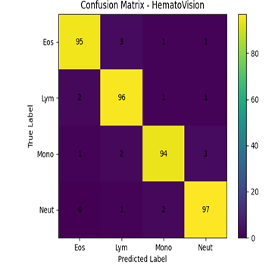
2 | Tune the Model | Hyperparameter Tuning: Learning Rate: 0.001 Batch Size: 32 Epochs: 10–15 Optimizer: Adam Loss Function: CrossEntropyLoss  Transfer Learning Model: ResNet18  Validation Method: Train-Test Split (80% Training, 20% Testing) Model validated on unseen test dataset. | 